

Student Debt Avoidance Program

(SDAP)

Career & College Report

Name

|  |  |
| --- | --- |
| **Graduation Year** |  |
| **GPA** |  |
| **ACT Score** |  |

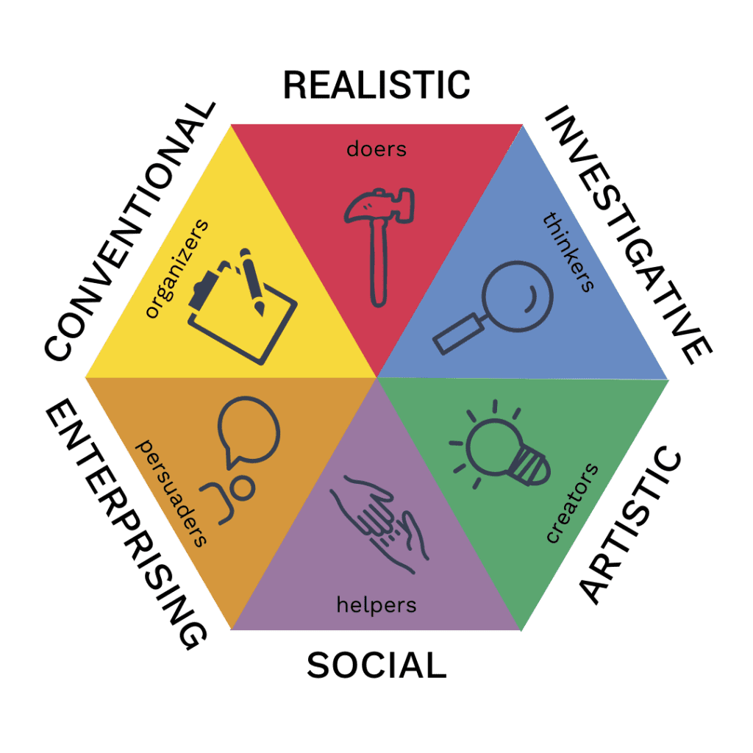

|  |  |
| --- | --- |
| **RIASEC Trait** | **Your Score** |
| Realistic |  |
| **Investigative** |  |
| Artistic |  |
| Social |  |
| Enterprising |  |
| **Conventional** |  |

**Realistic (doers)**

Assertive, competitive, and are interested in activities that require motor coordination, skill, and strength

* You like to work with your hands. This could mean working with tools, animals, metals, woods, and machines
* You may shy away from social situations involving teaching, speaking, or informing others
* You prefer practical things that can be seen or heard
* You may have a self-view that is practical in nature. You gravitate towards the mechanical
* You like work activities that include practical, hands-on problems and solutions.
* You typically enjoy outside work.
* You may not enjoy occupations that mainly involve doing a lot of paperwork or working closely with others.

**Investigative (thinkers)**

Like working with ideas and concepts and doing things that involve theory, research, and intellectual inquiry

* You like to investigate problems and find solutions.
* Math and science come naturally to you.
* You probably don’t like work involving sales, convincing people, or leading others.
* You put a premium on science and fact-based evidence
* You may view yourself as scientific.
* People think of you as the intellectual type
* You prefer work activities that have to do with ideas and thinking rather than physical activity.
* You like to search for facts and figure out problems mentally, rather than persuading or leading people.

**Artistic (creators)**

Enjoy thinking “outside of the box”. Like to find new and creative ideas, and enjoy seeing things from a different perspective.

* You gravitate towards creative activities, like music, art, drama, crafts, and writing.
* Repetitive activities or situations with a high degree of structure are turn-offs.
* You are naturally gifted with creative abilities that are used for drawing, writing, music, and acting.
* You may view yourself as independent, expressive, original, and contrarian.
* You enjoy work activities that deal with forms, designs, and patterns.
* You seek self-expression and work that can be done without following a clear set of rules.

**Social (helpers)**

Like to serve and help others. Tend to find great joy in forming close relationships with others.

* You naturally gravitate towards helping other people and it has likely been this way for you since childhood.
* Teaching, offering medical assistance, and providing information are all in your wheelhouse.
* You likely shy away from machines or tools.
* You are likely gifted with teaching, counseling, or in some way helping others.
* You are gifted at helping groups or finding solutions for social challenges.
* People may view you as intuitive, a healer, or even empathetic.
* You enjoy work activities that assist others and promote learning and personal development.
* You prefer to communicate more than to work with objects, machines, or data.

**Enterprising (persuaders)**

Like to lead people. Have excellent social skills and are good at persuading others (often described as being able to “sell ice to Eskimos”)

* You enjoy persuading people and leading groups or teams.
* Selling, persuading, and convincing people comes natural to you.
* Science and analytical thinking aren’t where you live.
* You are gifted with motivating people to a place of change.
* You have an entrepreneurial spirit and are a self-starter.
* You may place a premium on leadership skills or business accomplishments.
* You may see yourself as a “task-master” and the person who gets things done.
* You are great in social situations.
* You enjoy work activities that involve starting up, and carrying out projects.
* You like persuading and leading people, and making decisions.
* You like taking risks for profit.
* You prefer actions rather than thought.

**Conventional (organizers)**

Organized, accurate, and methodical. Like things to be done on time, and they strictly adhere to rules and regulations

* You likely gravitate towards work involving numbers.
* File management, recordkeeping, and operating machines that organize are in your wheelhouse.
* You aren’t a fan of unstructured environments, or work that is ambiguous in nature.
* You prefer working with systems that follow an orderly flow.
* You place a premium on success in business.
* People see you as the orderly type and excellent at following directions.
* You like work activities that follow set procedures and routines.
* You prefer working with data and details rather than ideas.
* You prefer work in which there are precise standards rather than having to judge things for yourself.
* You enjoy working where the lines of authority are clear.

**Matching Career Options**

### careers fit your personality (Conventional - Investigative)

# Require no diploma

## High School diploma

## Certificate

## Associate’s

## Bachelor’s

## Master’s

# Doctoral

=======================================================

Your My16 Personality Test (based on Myers-Briggs Type Indicator – MBTI) results are on the next page.

Your “best fit” careers based on your survey information, RIASEC (Holland) scores, and My16 scores are shown following the MBTI page.

**My16 Personality score:**

|  |  |  |  |  |
| --- | --- | --- | --- | --- |
| **Sensing Types** | | **Intuitive Types** | |  |
| **ISTJ** | **ISFJ** | **INFJ** | **INTJ** | **Introverts** |
| The Inspector | The Protector | The Counselor | The Mastermind |
| Honor and duty are what define you. You take any task seriously and give it more than your best. You are somewhat reserved and prefer to work alone, but can make a great team member if the need arises. You rely on logic and judge people based on how they present themselves to you. However, you tend to lose reason under enormous stress and act on your emotions. | You have a clear vision of how the world should be, and respect for tradition because they exist for a reason. You tend to believe the best of others, and are sensitive to their needs and desires. People see you as considerate, generous, and very reliable. However, without positive feedback, you may become discouraged. You like to feel appreciated for your efforts. | You are incredibly intuitive and confident about how the world functions, and you’re usually right. You believe in progress, and are constantly trying to improve yourself and the world around you. With others, you tend to be gentle and forgiving, but you have little tolerance for conflict, and you set high standards for yourself and those closest to you. | System and strategy are your favorite words. You’re insightful, ambitious, and dominating, but choose to remain quiet until the need for a leader arises. You see the big picture, and believe that details are useless unless they help achieve a goal. Your confidence makes you seem arrogant and elitist, but it’s hard to argue with you because you’re usually right. |
| **ISTP** | **ISFP** | **INFP** | **INTP** |
| The Crafter | The Composer | The Healer | The Architect |
| You are easily bored, and you enjoy thrill and action. You don’t really care for anything without a practical use. You believe in being impartial when it comes to making judgments, and you tend to ignore your own feelings and emotions for this reason, which may become overwhelming. Tasks that require hand to eye coordination and logic help to keep your mind focused. | You live for beauty and sensation, and have a strong appreciation for the arts. You have no desire to change or control, but you genuinely care for others, and reveal that through your respect and sympathy. To you, the world is simply the way it is, and it’s all a matter of how we fit ourselves into it. However, you can be unnecessarily harsh with yourself if you fail to be your own vision. | Your sincerity and intuition make you a good listener, and people are quick to confide in you. You are an idealist, and you are constantly searching for a meaning in life. Because of this, you have high standards and may prefer to work alone. You would do almost anything to avoid conflict, but can be moved to act emotionally and irrationally if your ideals are violated. | You fit quite well into the stereotype of “mad scientist”. To you, the world is about generating new theories, questioning those that already exist, and figuring out how things can be further improved. Your ability to see things objectively makes you very tolerant of new ideas. You are usually awkward, but confident and willing when asked to discuss a familiar topic. |
| **ESTJ** | **ESFJ** | **ENFJ** | **ENTJ** | **Extravert**s |
| The Supervisor | The Provider | The Teacher | The Field Marshall |
| Everything around you needs to be working, and in place to satisfy you. You’re confident, critical, and often aggressive. You take your duties very seriously and value strict social order. When upset you tend to feel alone and underappreciated, and although you usually like to make yourself heard, you have a hard time expressing your feelings and emotions in words. | You’re kind and understanding and you bring out the best in others. You enjoy making others happy, and have a hard time understanding indifference. Your morals and ethics are central to your person, and you would rather die than violate them. You also enjoy peace and structure, and often attempt to control your environment and the people around you to fit your idea of order. | You have a gift with people. They love to be around you because you’re bright and inspirational, but also considerate and supportive. You know what upsets and pleases them. You enjoy being at the center of attention, and are a natural teacher and leader. You’re also very good at developing and maintaining intimate relationships because your loved ones know they can trust you. | Born to be a leader, you’re tireless, strict, and infallible. You have little patience for those who don’t share your goals and intimidate them into working for you. You’re quick and decisive, and your intuition is usually right. You love to talk, especially if it’s a good argument. Emotion is not something you reveal to just anyone, and you show very little empathy. |
| **ESTP** | **ESFP** | **ENFP** | **ENTP** |
| The Promoter | The Performer | The Champion | The Inventor |
| A risk-taker, outgoing and fun-loving, you always live in the moment. You easily pick up on the attitudes and motivations of others, and respond bluntly. Rules don’t mean much to you – you’d prefer to do your own thing. You’re excitable and your enthusiasm is often contagious to those around you. Because of this you tend to start multiple projects but never finish any of them. | You absolutely love attention, but at the same time you’re very sympathetic toward others. You’re fun and lively, and are generally very accepting of everyone you meet and treat them all with equal kindness and generosity. You appreciate art and nature, and can connect well with animals and children. A great team member, you do your part willingly without complaints. | Full of potential and always alert, you learn quickly and seem to be good at everything you do. You’re warm and enthusiastic, and you have a strong desire to be liked by everyone. You are also easily distracted, and need the reminders of others to follow through with what you’ve started. You believe that you are constantly evolving and searching for inner peace. | You are constantly coming up with new ideas and possibilities, but sometimes unsure of how to carry them out. Quick and intuitive, you are good at making the right decision given a short amount of time. Your responses in debate are fast, but fluent and well-spoken. However you tend to dismiss input of others, and can become harsh and aggressive if challenged. |

**Top Career Matches based on your personality & survey answers**

(listed in alphabetical order, not in order of match, salary, or priority)

|  |  |  |  |  |
| --- | --- | --- | --- | --- |
| Career | Training | Major | Starting Salary | Median Salary |
| Accountant | Bachelor’s | Accounting | $48,560 | $78,000 |
| Actuary | Bachelor’s | Math | $71,760 | $113,990 |
| Archivist | Master’s | History | $35,110 | $58,640 |
| Budget Analyst | Bachelor’s | Economics | $53,000 | $82,260 |
| Bus. Intelligence | Bachelor’s | Informatics | $58,510 | $103,500 |
| Credit Analyst | Bachelor’s | Finance | $47,960 | $78,850 |
| Data Scientist | Bachelor’s | Informatics | $58,510 | $103,500 |
| Logistician | Bachelor’s | Supply Chain | $46,260 | $77,520 |
| Mathematician | Master’s | Math | $57,680 | $112,110 |
| RFID Specialist | Bachelor’s | Engineering | $74,880 | $108,170 |
| Statistician | Master’s | Math | $58,090 | $98,920 |
| Technical Writer | Bachelor’s | Communications | $47,460 | $79,960 |

**Detailed Information About Career Options**

(<left click> on hyperlinks for info on that career, and how to become one)

Each of the links below contain huge amounts of information about each career including day-to-day activities, skills, how to get started, and even regional and national salaries and growth projections.

**Accountant**

[13-2011.00 - Accountants and Auditors (onetonline.org)](https://www.onetonline.org/link/summary/13-2011.00)

[How to become an accountant - CareerExplorer](https://www.careerexplorer.com/careers/accountant/how-to-become/)

**Actuary**

[15-2011.00 - Actuaries (onetonline.org)](https://www.onetonline.org/link/summary/15-2011.00)

[How to become an actuary - CareerExplorer](https://www.careerexplorer.com/careers/actuary/how-to-become/)

**Archivist**

[25-4011.00 - Archivists (onetonline.org)](https://www.onetonline.org/link/summary/25-4011.00)

[How to become an archivist - CareerExplorer](https://www.careerexplorer.com/careers/archivist/how-to-become/)

**Budget Analyst**

[13-2031.00 - Budget Analysts (onetonline.org)](https://www.onetonline.org/link/summary/13-2031.00)

[How to become a budget analyst - CareerExplorer](https://www.careerexplorer.com/careers/budget-analyst/how-to-become/)

**Business Intelligence Analyst**

[15-2051.01 - Business Intelligence Analysts (onetonline.org)](https://www.onetonline.org/link/summary/15-2051.01)

[How to become a business analyst - CareerExplorer](https://www.careerexplorer.com/careers/business-analyst/how-to-become/)

**Credit Analyst**

[13-2041.00 - Credit Analysts (onetonline.org)](https://www.onetonline.org/link/summary/13-2041.00)

[How to become a credit analyst - CareerExplorer](https://www.careerexplorer.com/careers/credit-analyst/how-to-become/)

**Data Scientist**

[15-2051.00 - Data Scientists (onetonline.org)](https://www.onetonline.org/link/summary/15-2051.00)

[How to become a data scientist - CareerExplorer](https://www.careerexplorer.com/careers/data-scientist/how-to-become/)

**Logistician**

[13-1081.00 - Logisticians (onetonline.org)](https://www.onetonline.org/link/summary/13-1081.00)

[How to become a logistician - CareerExplorer](https://www.careerexplorer.com/careers/logistician/how-to-become/)

**Mathematician**

[15-2021.00 - Mathematicians (onetonline.org)](https://www.onetonline.org/link/summary/15-2021.00)

[How to become a mathematician - CareerExplorer](https://www.careerexplorer.com/careers/mathematician/how-to-become/)

**Radio Frequency ID Specialist**

[17-2072.01 - Radio Frequency Identification Device Specialists (onetonline.org)](https://www.onetonline.org/link/summary/17-2072.01)

[How to become a radio frequency specialist - CareerExplorer](https://www.careerexplorer.com/careers/radio-frequency-specialist/how-to-become/)

**Statistician**

[15-2041.00 - Statisticians (onetonline.org)](https://www.onetonline.org/link/summary/15-2041.00)

[How to become a statistician - CareerExplorer](https://www.careerexplorer.com/careers/statistician/how-to-become/)

**Technical Writer**

[27-3042.00 - Technical Writers (onetonline.org)](https://www.onetonline.org/link/summary/27-3042.00)

[How to become a technical writer - CareerExplorer](https://www.careerexplorer.com/careers/technical-writer/how-to-become/)

**Annual Cost for Education or Training**

Most cost-effective options. Includes tuition, room & board, fees, books, travel, $2k/yr for misc.

Costs include all published merit scholarships based on GPA/ACT score.

Only schools offering the major associated with the profession are included.

Costs are for incoming Freshmen attending all 4 yrs. Transfer student costs will vary due to awards

|  |  |  |  |  |
| --- | --- | --- | --- | --- |
| Career | Commuter  (live at home) | IL Public  (on-campus) | Online  (live at home) | Christian (on-campus) |
| Accountant | $21,315 | $23,514 | $10,000 | $3,704** |
| Actuary | $21,024 | $23,514 | $13,100 | $16,264 |
| Archivist* | $21,024 | $23,514 | $8,664 | $16,264 |
| Budget Analyst | $21,024 | $23,514 | $11,480 | $21,347 |
| Bus. Intelligence | $21,315 | $23,514 | $11,480 | $21,347 |
| Credit Analyst | $21,315 | $23,514 | $10,000 | $16,265 |
| Data Scientist | $21,315 | $23,514 | $11,480 | $21,347 |
| Logistician | n/a | $23,514 | $10,000 | $24,882 |
| Mathematician* | $21,024 | $23,514 | $13,100 | $16,264 |
| RFID Specialist | $33,162 | $23,514 | $13,700 | $16,264 |
| Statistician* | $21,024 | $23,514 | $13,100 | $16,264 |
| Technical Writer | $21,315 | $23,514 | $10,483 | $19,796 |

* Typically requires a graduate degree. The costs shown are for undergraduate study only.

Assumes graduate costs can be offset with salary from Graduate or Teaching Assistantships.

** This is one of the very few times it is *not* more cost-effective to do 2 yrs at Community College.

**Total Debt after getting Bachelor’s Degree**

|  |  |  |  |  |
| --- | --- | --- | --- | --- |
| Career | Commuter | On-Campus | Online | Christian |
| Accountant | $5,080 | $12,607 | $17,551 | $5,988 |
| Actuary | $7,131 | $12,607 | $11,351 | $7,428 |
| Archivist | $5,080 | $12,607 | $20,223 | $216 |
| Budget Analyst | $5,080 | $12,607 | $14,591 | $7,428 |
| Bus. Intelligence | $5,080 | $12,607 | $11,480 | $10,674 |
| Credit Analyst | $5,080 | $12,607 | $17,551 | $9,041 |
| Data Scientist | $5,080 | $12,607 | $14,591 | $10,674 |
| Logistician | n/a | $16,477 | $17,551 | $17,214 |
| Mathematician | $7,131 | $12,607 | $11,351 | $7,428 |
| RFID Specialist | $19,930* | $12,607 | $10,151 | $7,428 |
| Statistician | $7,131 | $12,607 | $11,351 | $7,428 |
| Technical Writer | $5,080 | $12,607 | $16,585 | $9,041 |

**Red** indicates the amount of money you will have to borrow;

**Blue** indicates the amount you will have left over in your savings account

Assumptions:

* Lowest cost school in that category is selected
* Start off with **no money saved**
* No grants or additional scholarships beyond published merit
* Attend ICC for 2 years
* Qualify for Peoria Promise
* Work ($14.00/hr):

Summer/Winter: 40 hrs/wk

Fall/Spring: 12 hrs/wk

**Closing Thoughts**

While the above gives estimates based on real data from US Bureau of Labor & Statistics and the college websites and it is useful for planning purposes, it is important for you to verify each element on your own.

When choosing a career it is important that you learn as much as you possibly can about that career through the links in this document, through talking to those who currently work in that profession or have experience working in that profession, and from any other resources you can find.

If your chosen career requires college, you will definitely have times of frustration, worry, and discouragement. Having a clear vision of your goal, and a clear understanding of what lies ahead and why you are putting forth such an effort is the best way to persevere during those difficult times and to succeed in completing the requisite training.

I am always available to discuss your options, answer any questions, or put you in touch with someone experienced in your chosen profession.

Also, I’ll be happy to provide the names of each college used to generate the numbers in the tables.

And if you are interested I will send you two interactive spreadsheets where you can explore all of your options by choosing different careers, colleges, lifestyles, etc.

**Remember, there is never any cost or obligation.**

Greg Gipp

(309) 339-8647

[gippgreg@sbcglobal.net](mailto:gippgreg@sbcglobal.net)